

Assignment

On

Artificial Intelligence Lab (1)

Course Title: Artificial Intelligence

Course Code: CSE 418

Submitted To:

Richard Philips

Lecturer Dept. of Computer Science Engineering

Submitted By:

Most. Saher Banu

Id# 143372002

Program: B.CSE

Batch: 37th
Family Tree Design:
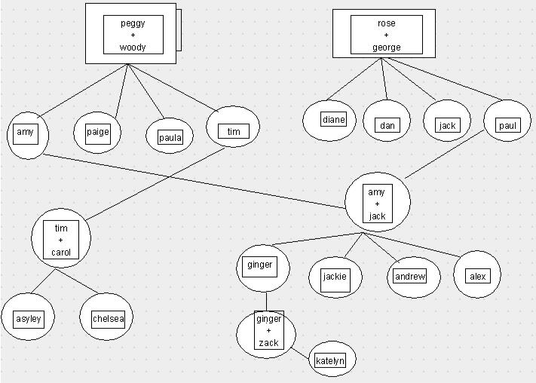

parent(peggy, amy).

parent(peggy, paige).

parent(peggy, paula).

parent(peggy, tim).

parent(woody, amy).

parent(woody, paige).

parent(woody, paula).
parent(woody, tim).

parent(rose, dianne).

parent(rose, dan).

parent(rose, jack).

parent(rose, paul).

parent(george, dianne).

parent(george, dan).

parent(george, jack).

parent(george, paul).

parent(amy, ginger).

parent(amy, jackie).

parent(amy, andrew).

parent(amy, alex).

parent(jack, ginger).

parent(jack, jackie).

parent(jack, andrew).
parent(jack, alex).

parent(ginger, katelyn).

parent(zack, katelyn).

parent(tim, carol).

parent(carol, ashley).

parent(carol, Chelsea)

